“ Mastering Embedded System Online Diploma ”
“ First Term ( High Presuure Detection ) ”
Engineer : Ahmed ELsayed Sabra. ID : YRP3126883090
My Profile : https://www.learn-in-depth-store.com/profile/a-sabra44473878/profile
- Case Study :
The client expects the delivery of the software of the following system:
- A pressure detection system that informs the crew of a cabin with an alarm when the pressure exceeds 20 bars in the cabin.
- The alarm duration equals 60 seconds.
Assumptions :
- The controller setup and shut down procedures are not modeled.
- The controller maintenance is not modeled.
- The pressure sensor never fails.
- The alarm never fails.
- The controller never faces power cut.
- Methiod :
The chosen method in designing and implementing this system is the V-model method.
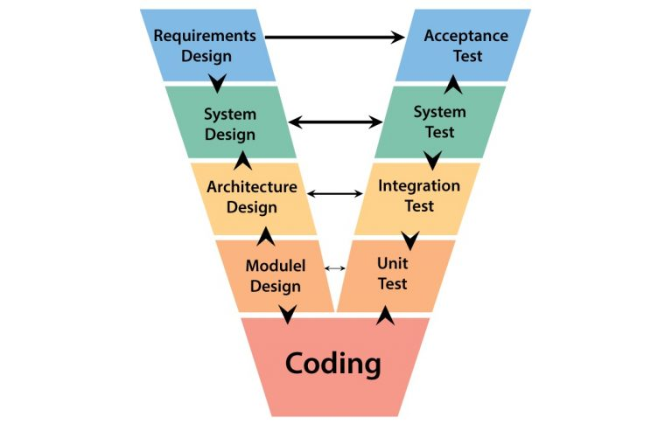

- Space exploration and hardware / software partitioning :
- Hardware :
Controller: STM32F103C6.
Alarm: LED.
Sensor: Pressure sensor.
- Software :
Pressure sensor driver.
Main algorithm.
Alarm monitor.
Alarm actuator driver.
- Requirement :
After talking with the customer, I got the requirements of this project and then I show the requirements diagram to the customer to ensure its right or not.
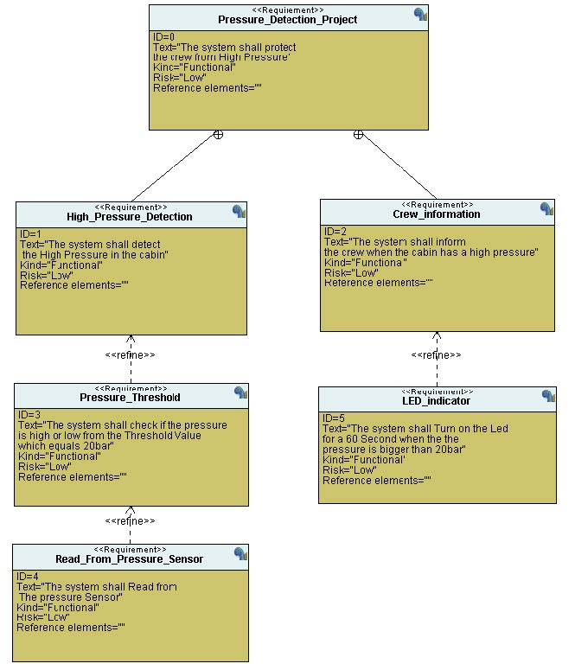
- System Analysis :
- Use Case Digram ::
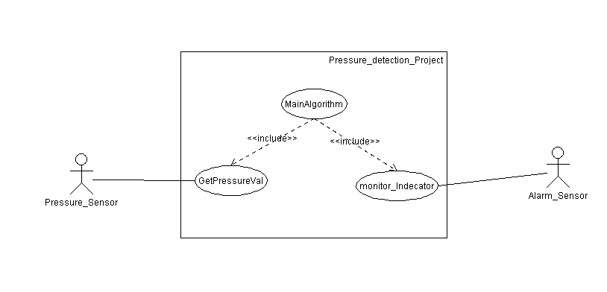
System boundary and main functions. Not describe step by step algorithm.
- Activity Digram :
Describe the workflow behavior of a system.
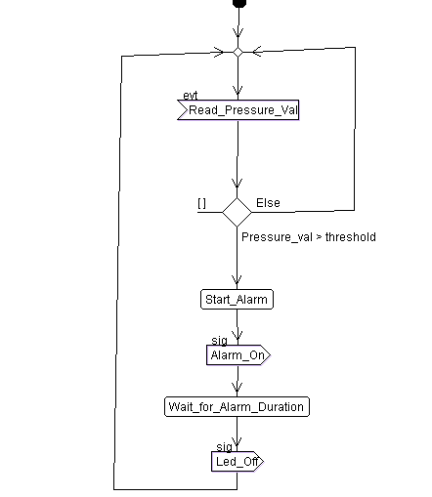

- Sequence Diagram
If Pressure Value is bigger than 20bar the indicator will start and wait for 60 seconds.

- System Design
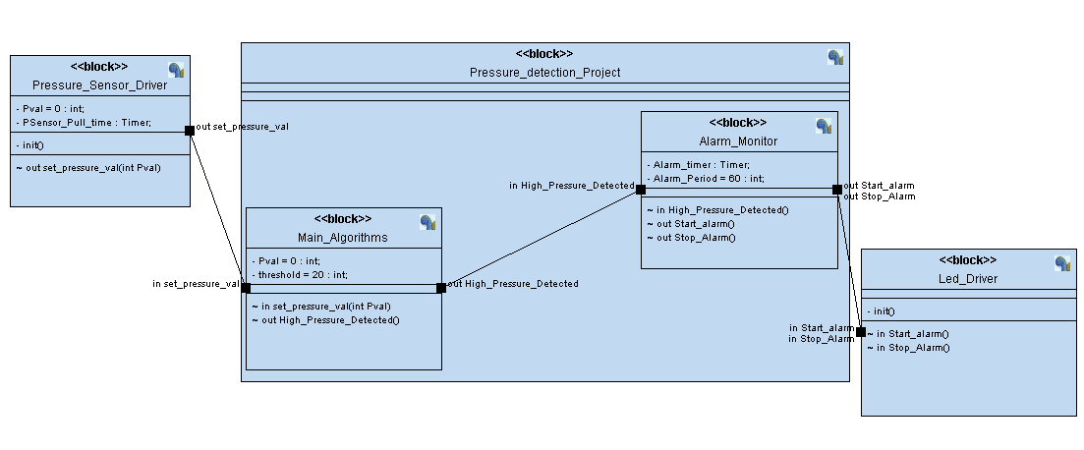

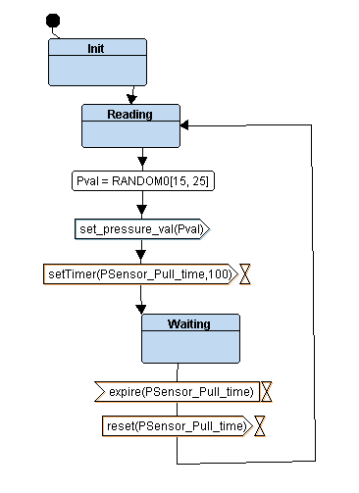
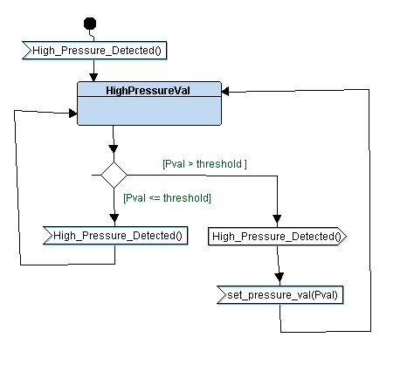
- Pressure Sensor Block * Main Algorithms
- Alarm Monitor * Led Driver
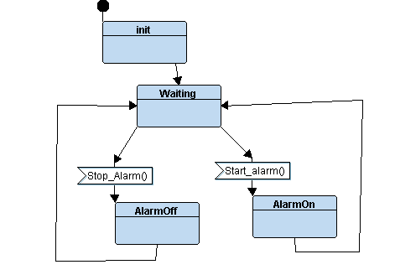
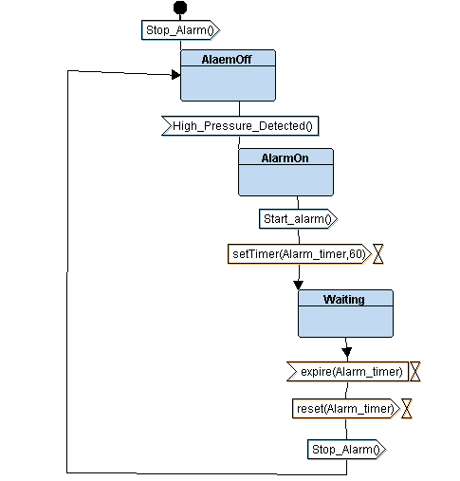

- Analysis and Timing Diagram
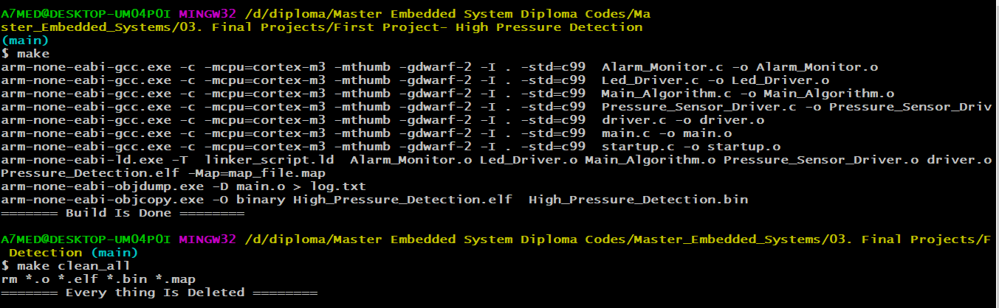
“Build Project By Make File ”

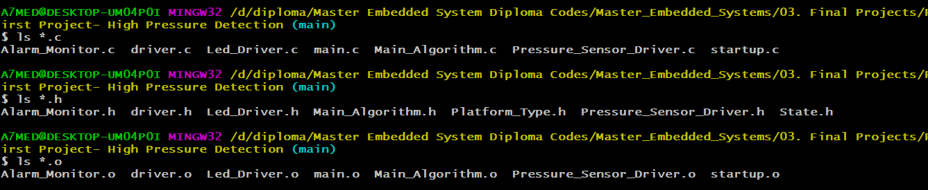
“ Simulation Project By Proteus ”
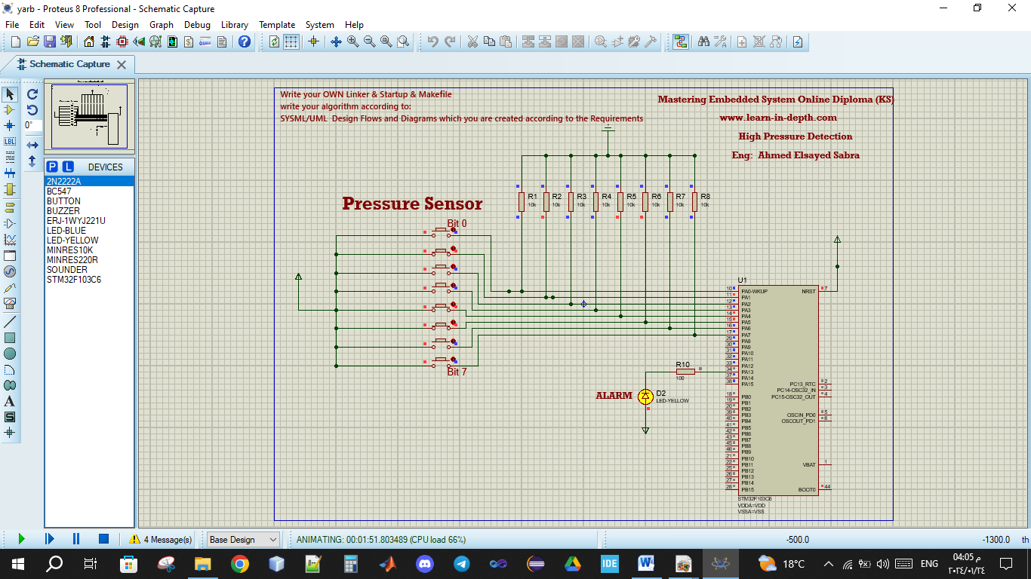

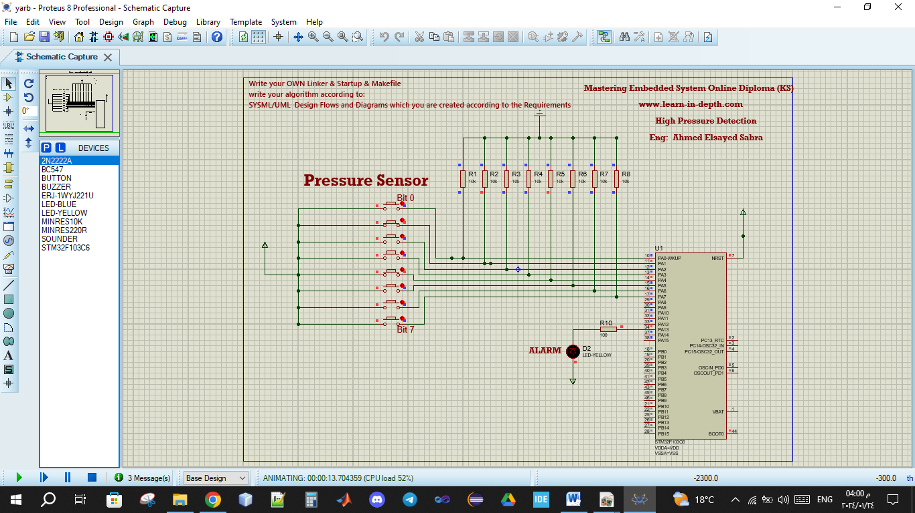

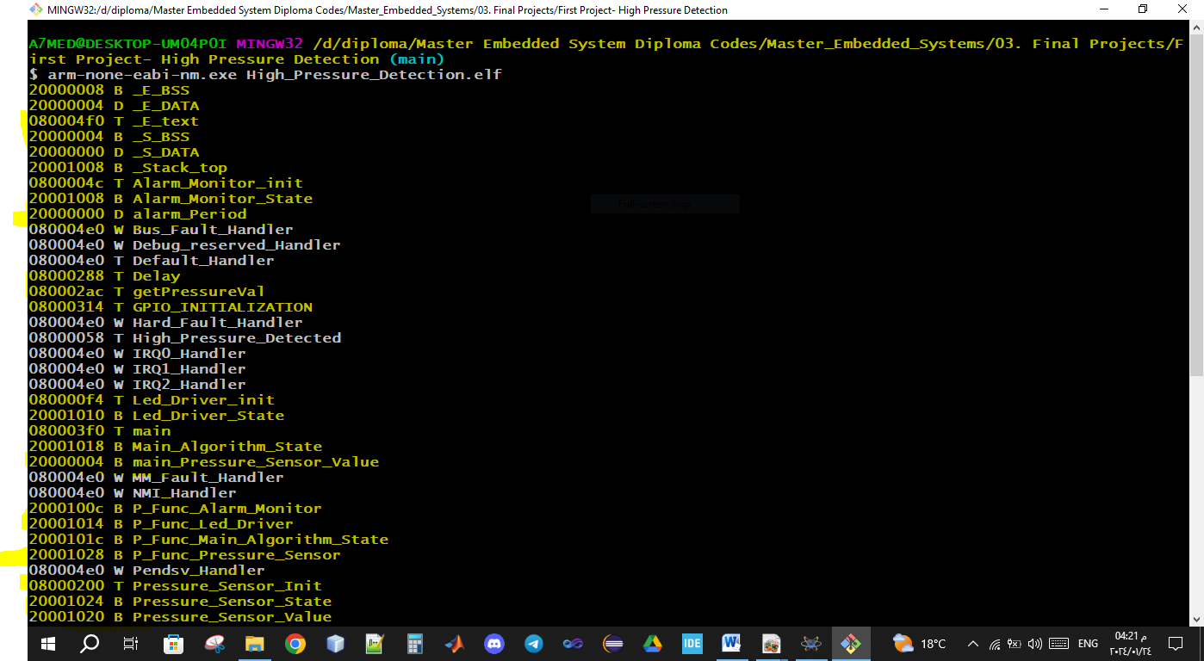
“Analysis Software - Data Section foe System && Showing All Symbol ”
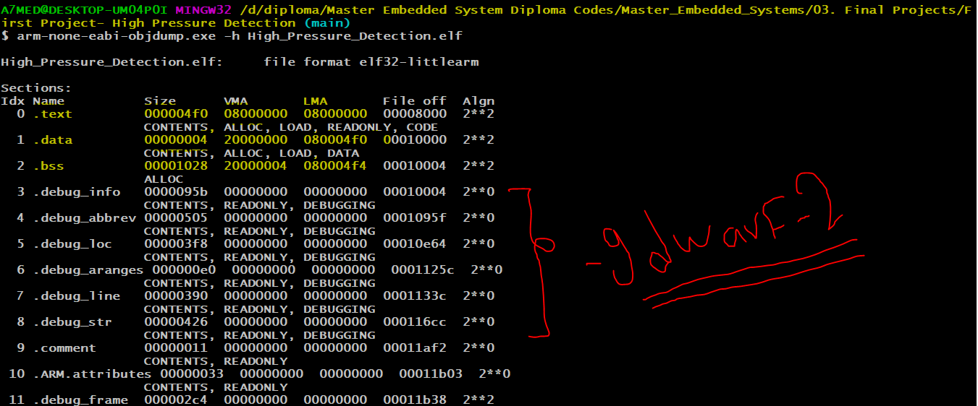
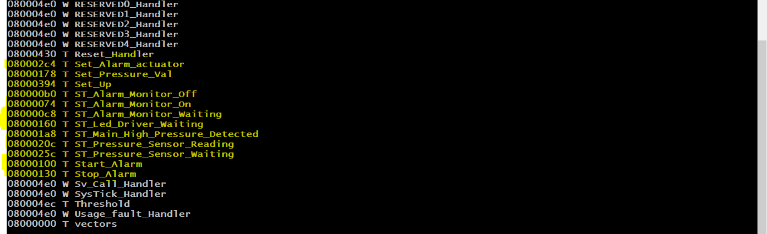
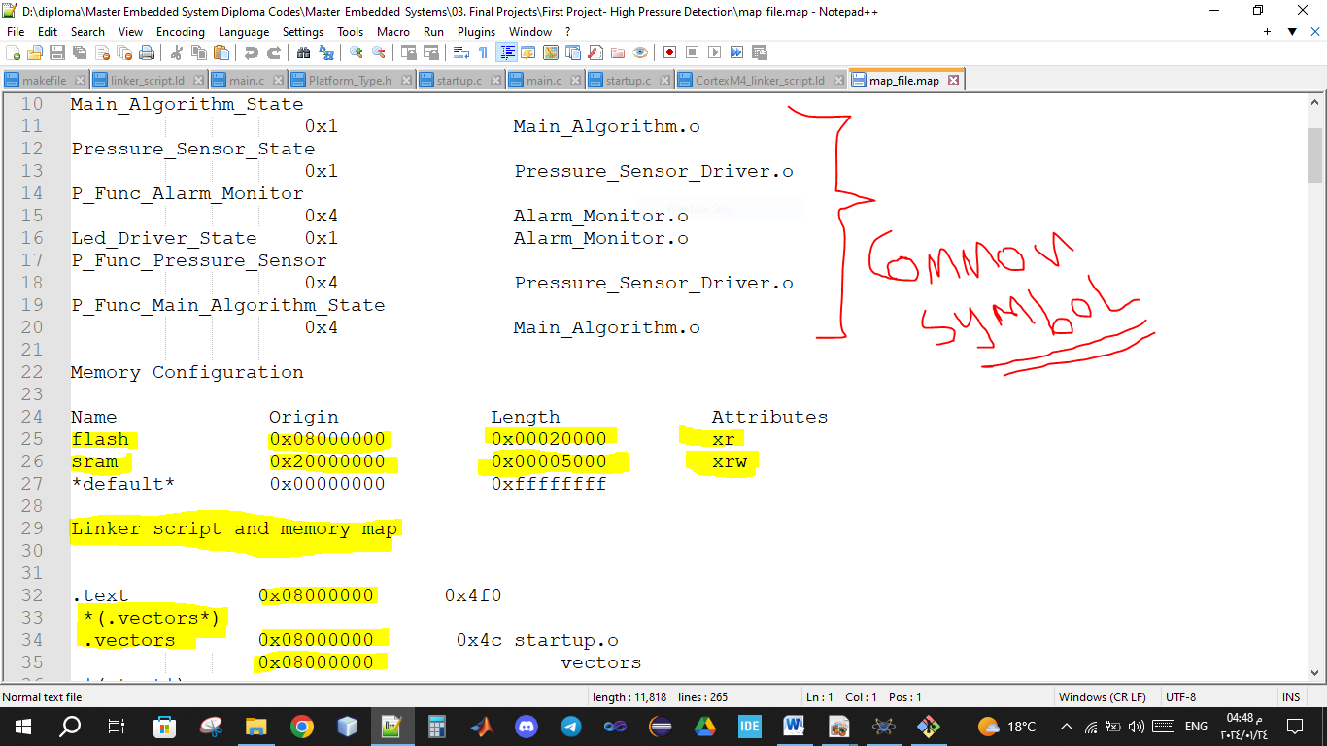
“Analysis Map File “

“Log File ”
